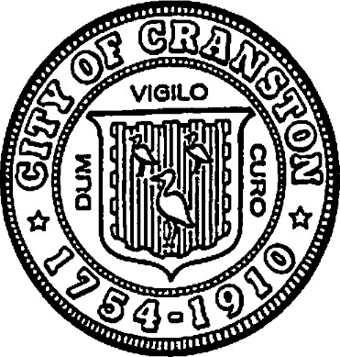

CITY OF CRANSTON

NOTICE OF FUND AVAILABILITY AND

2021-2022 PROGRAM MID-YEAR UPDATE

A public hearing to monitor progress made by organizations receiving "CDBG" funding during fiscal year July 1, 2021 — June 30, 2022 will be held on:

Monday, January 24th, 2022

Place: Cranston Senior Center

1070 Cranston Street, Cranston, RI 02920

Time: 5:00-7:00 PM

CDBG funds can be spent on neighborhood improvements, some public facilities, public services, economic development and housing rehabilitation. CDBG funds are used, primarily, to benefit low to moderate-income people.

This forum will be used to formally announce that the estimated allocation for the City of Cranston will be $ 1,000,000.00 in Community Development Block Grant Funds for the program year beginning July 1, 2022. Any person or organization interested in applying for these funds is urged to attend. Applications will be available at the hearing.

Additional information and applications may be obtained by calling the Department of Community Development between the hours of 8:30AM and 4:30PM at 401-780-6240, visiting the department website at cranstonri.gov or our office at 35 Sockanossett Crossroad, Unit 6 Cranston, RI 02920.

|  |  |
| --- | --- |
| Kenneth J. Hopkins | Timothy G. Sanzi |
| Mayor, City of Cranston | Community Development Director |
|  |  |
|  |  |